**CURRICULIM CODE: 6740**

**DREAMWEAVER E-PROJECT** **Gracious Garments.com**

**Group members:**

* TAHA NAEEM
* DAWOOD ALI
* SYED AMMAR ALI
* FAHAD JAWEED

**SUBMITTED TO:**

[‘eprojects@aptech.ac.in](mailto:eprojects@aptech.ac.in)

**PROJECT INSTRUCTOR:**

‘MS RABIA AMIN’



HOME PAGE OF MY WEBSITE

THIS IS WEBSITE ABOUT GARMENTS AND SHOES OF DIFFERENT BRANDS WHICH INCLUDE MENS WEAR WHICH HAS CASUAL PARTY FORMAL WEAR IN WOMENSWEAR WHICH HAS CASUAL PARTY AND FORMAL DRESSES ,

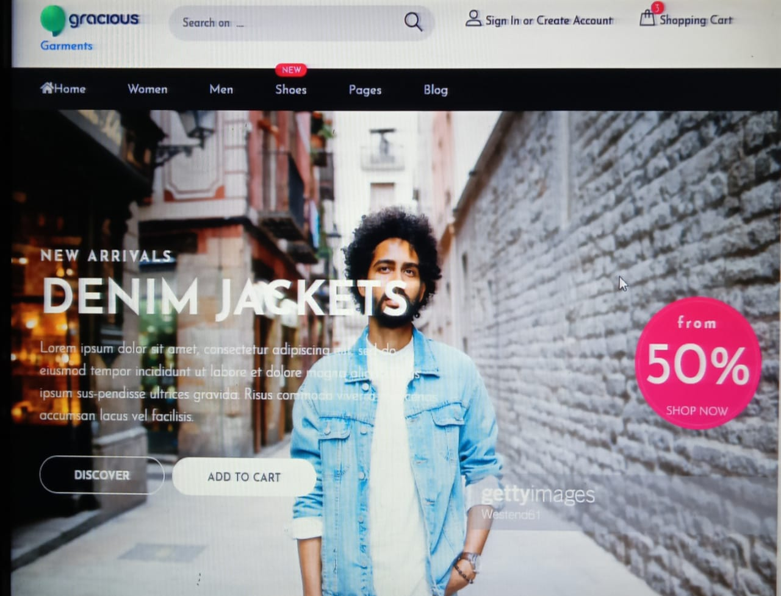



By clicking on these button you will reach the   
appropriate nav-item. this is site (different garment products) about men’s and women’s wear and different variety of shoes.

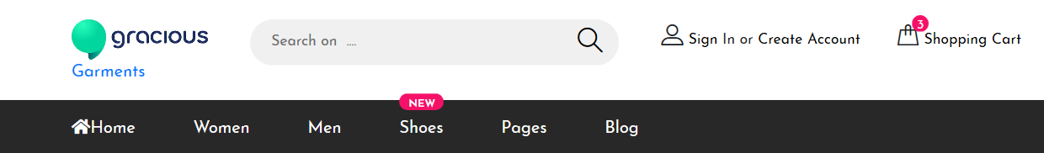

“DIFFERENT GARMENTS PRODUTS OF MEN’S WEAR”

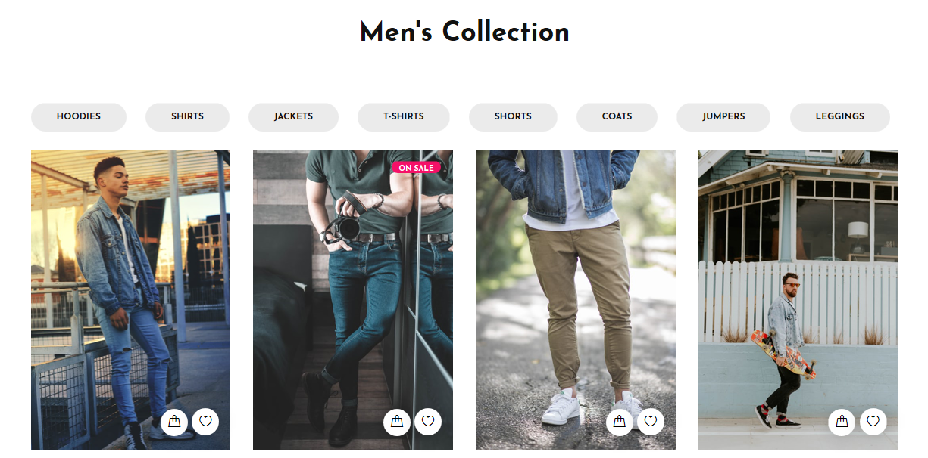



Website also about the product ‘’SHOE’S’’ of   
different brand’s as this website is  
 about online shopping , by clicking the shoes section you can see a unique variety of shoes which include formal casual also !

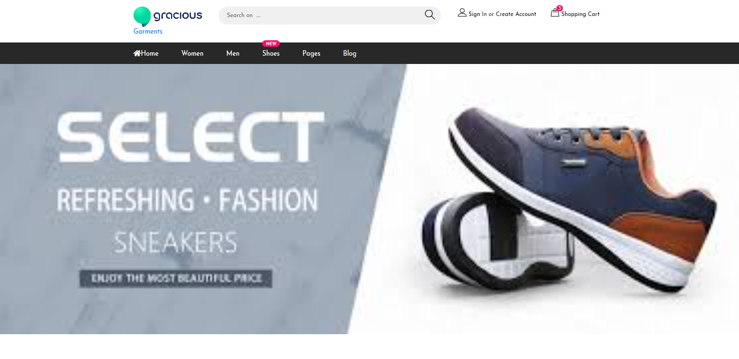



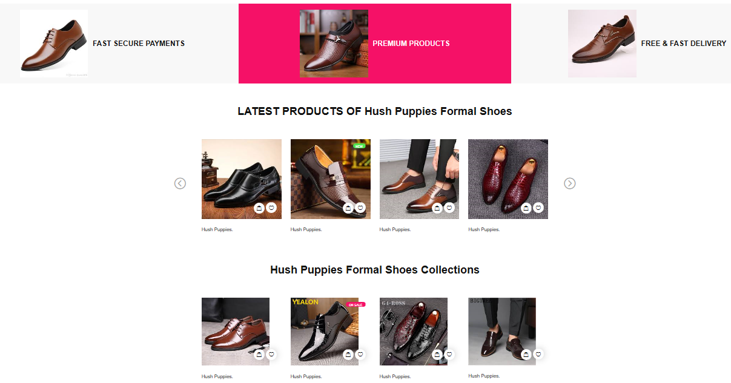Formal shoes

Sandal’s collection

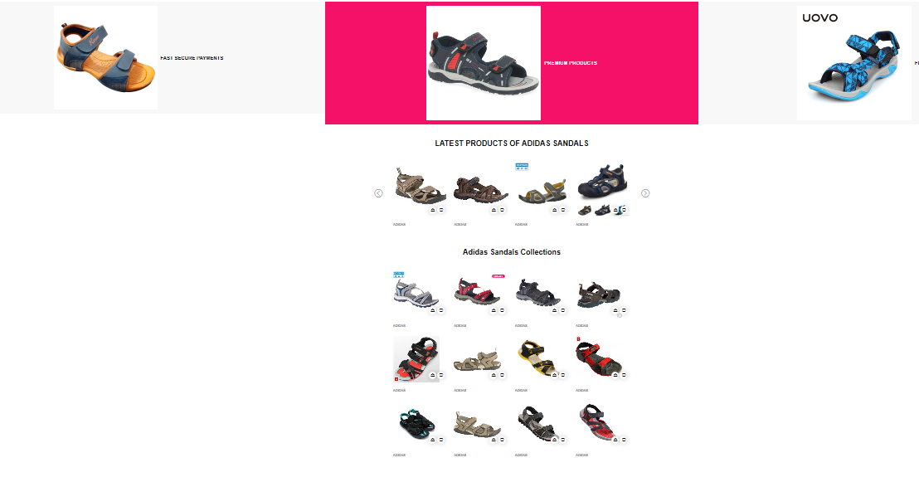

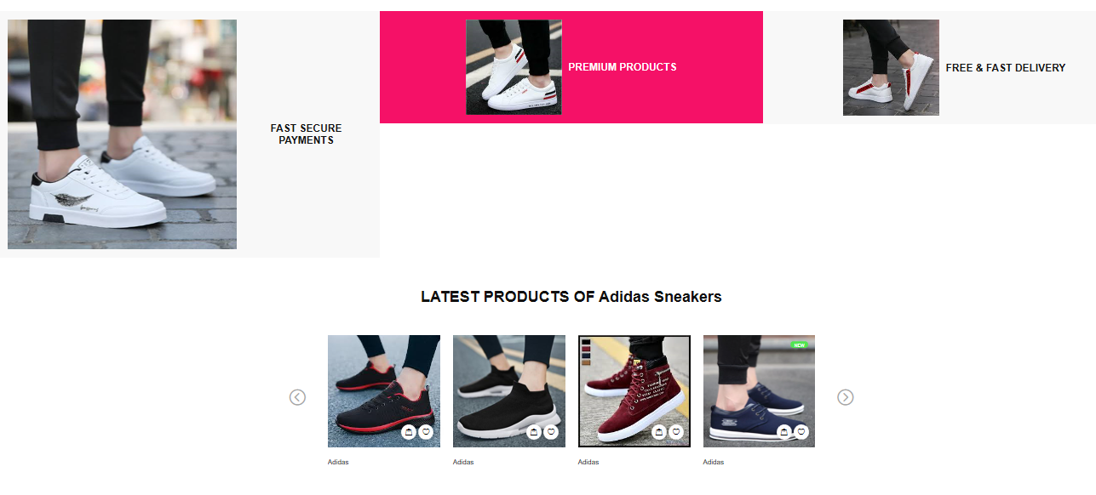

Sneaker’s collection



website also have a blog site

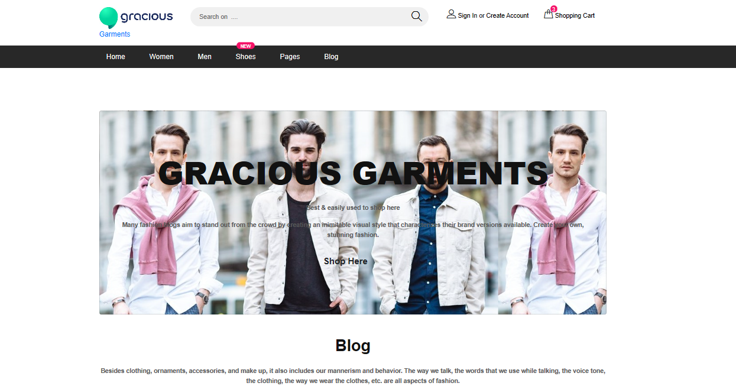

Source Code

|  |
| --- |
| <head> |
|  | <title>Gracious Garments</title> |
|  | <meta charset="UTF-8"> |
|  | <meta name="description" content="This is our Best"> |
|  | <meta name="keywords" content=""> |
|  | <meta name="viewport" content="width=device-width, initial-scale=1.0"> |
|  |  |
|  | <!-- Font Awesome --> |
|  | <link rel="stylesheet" href="<https://use.fontawesome.com/releases/v5.8.2/css/all.css>"> |
|  | <!-- Bootstrap core CSS --> |
|  | <link href="<https://cdnjs.cloudflare.com/ajax/libs/twitter-bootstrap/4.3.1/css/bootstrap.min.css>" rel="stylesheet"> |
|  | <!-- Material Design Bootstrap --> |
|  | <link href="<https://cdnjs.cloudflare.com/ajax/libs/mdbootstrap/4.8.10/css/mdb.min.css>" rel="stylesheet"> |
|  |  |
|  | <!-- JQuery --> |
|  | <script type="text/javascript" src="<https://cdnjs.cloudflare.com/ajax/libs/jquery/3.4.1/jquery.min.js>"></script> |
|  | <!-- Bootstrap tooltips --> |
|  | <script type="text/javascript" src="<https://cdnjs.cloudflare.com/ajax/libs/popper.js/1.14.4/umd/popper.min.js>"></script> |
|  | <!-- Bootstrap core JavaScript --> |
|  | <script type="text/javascript" src="<https://cdnjs.cloudflare.com/ajax/libs/twitter-bootstrap/4.3.1/js/bootstrap.min.js>"></script> |
|  | <!-- MDB core JavaScript --> |
|  | <script type="text/javascript" src="<https://cdnjs.cloudflare.com/ajax/libs/mdbootstrap/4.8.10/js/mdb.min.js>"></script> |
|  |  |
|  |  |
|  | <!-- Google Font --> |
|  | <link href="<https://fonts.googleapis.com/css?family=Josefin+Sans:300,300i,400,400i,700,700i>" rel="stylesheet"> |
|  |  |
|  | <!-- Stylesheets --> |
|  | <link rel="stylesheet" href="[css/bootstrap.min.css](file:///C:\\Users\\m.a\\Desktop\\New%20folder\\Gracious%20Garments\\css\\bootstrap.min.css" \t "_blank)"/> |
|  | <link rel="stylesheet" href="[css/font-awesome.min.css](file:///C:\\Users\\m.a\\Desktop\\New%20folder\\Gracious%20Garments\\css\\font-awesome.min.css" \t "_blank)"/> |
|  | <link rel="stylesheet" href="[css/flaticon.css](file:///C:\\Users\\m.a\\Desktop\\New%20folder\\Gracious%20Garments\\css\\flaticon.css" \t "_blank)"/> |
|  | <link rel="stylesheet" href="[css/slicknav.min.css](file:///C:\\Users\\m.a\\Desktop\\New%20folder\\Gracious%20Garments\\css\\slicknav.min.css" \t "_blank)"/> |
|  | <link rel="stylesheet" href="[css/jquery-ui.min.css](file:///C:\\Users\\m.a\\Desktop\\New%20folder\\Gracious%20Garments\\css\\jquery-ui.min.css" \t "_blank)"/> |
|  | <link rel="stylesheet" href="[css/owl.carousel.min.css](file:///C:\\Users\\m.a\\Desktop\\New%20folder\\Gracious%20Garments\\css\\owl.carousel.min.css" \t "_blank)"/> |
|  | <link rel="stylesheet" href="[css/animate.css](file:///C:\\Users\\m.a\\Desktop\\New%20folder\\Gracious%20Garments\\css\\animate.css" \t "_blank)"/> |
|  | <link rel="stylesheet" href="[css/style.css](file:///C:\\Users\\m.a\\Desktop\\New%20folder\\Gracious%20Garments\\css\\style.css" \t "_blank)"/> |
|  |  |
|  |  |
|  | <!--[if lt IE 9]> |
|  | <script src="https://oss.maxcdn.com/html5shiv/3.7.2/html5shiv.min.js"></script> |
|  | <script src="https://oss.maxcdn.com/respond/1.4.2/respond.min.js"></script> |
|  | <![endif]--> |
|  |  |
|  | </head> |

Linking

|  |
| --- |
| <nav class="main-navbar"> |
|  | <div class="container"> |
|  | <!-- menu --> |
|  | <ul class="main-menu"> |
|  | <li><a href="[index.html](file:///C:\Users\m.a\Desktop\New%20folder\Gracious%20Garments\index.html)"><i class="fas fa-home"></i>Home</a></li> |
|  | <li><a href="[#](file:///C:\Users\m.a\Desktop\New%20folder\Gracious%20Garments\index.html)">Women</a></li> |
|  | <li><a class="scroll-smooth" href="[#Men](file:///C:\Users\m.a\Desktop\New%20folder\Gracious%20Garments\index.html#Men)">Men</a></li> |
|  | <li><a href="[#](file:///C:\Users\m.a\Desktop\New%20folder\Gracious%20Garments\index.html)">Shoes <span class="new">New</span></a> |
|  | <ul class="sub-menu"> |
|  | <li><a href="[sneakers.html](file:///C:\Users\m.a\Desktop\New%20folder\Gracious%20Garments\sneakers.html)">Sneakers</a></li> |
|  | <li><a href="[sandals.html](file:///C:\Users\m.a\Desktop\New%20folder\Gracious%20Garments\sandals.html)">Sandals</a></li> |
|  | <li><a href="[formal shoes.html](file:///C:\Users\m.a\Desktop\New%20folder\Gracious%20Garments\formal%20shoes.html)">Formal Shoes</a></li> |
|  | <li><a href="[boots.html](file:///C:\Users\m.a\Desktop\New%20folder\Gracious%20Garments\boots.html)">Boots</a></li> |
|  | <li><a href="[Flip Flops.html](file:///C:\Users\m.a\Desktop\New%20folder\Gracious%20Garments\Flip%20Flops.html)">Flip Flops</a></li> |
|  | </ul> |
|  | </li> |
|  | <li><a href="[#](file:///C:\Users\m.a\Desktop\New%20folder\Gracious%20Garments\index.html)">Pages</a> |
|  | <ul class="sub-menu"> |
|  | <h6 style="color:firebrick ;">Products</h6> |
|  | <li><a href="[product.html](file:///C:\Users\m.a\Desktop\New%20folder\Gracious%20Garments\product.html)">Product Page-1</a></li> |
|  | <li><a href="[product2.html](file:///C:\Users\m.a\Desktop\New%20folder\Gracious%20Garments\product2.html)">Product Page-2</a></li> |
|  | <li><a href="[product3.html](file:///C:\Users\m.a\Desktop\New%20folder\Gracious%20Garments\product3.html)">Product Page-3</a></li> |
|  | <li><a href="[product4.html](file:///C:\Users\m.a\Desktop\New%20folder\Gracious%20Garments\product4.html)">Product Page-4</a></li> |
|  | <li><a href="[product5.html](file:///C:\Users\m.a\Desktop\New%20folder\Gracious%20Garments\product5.html)">Product Page-5</a></li> |
|  | <li><a href="[product6.html](file:///C:\Users\m.a\Desktop\New%20folder\Gracious%20Garments\product6.html)">Product Page-6</a></li> |
|  | <h6 style="color: firebrick;">Categories</h6> |
|  | <li><a href="[categories.html](file:///C:\Users\m.a\Desktop\New%20folder\Gracious%20Garments\categories.html)">Category Page-1</a></li> |
|  | <li><a href="[categories2.html](file:///C:\Users\m.a\Desktop\New%20folder\Gracious%20Garments\categories2.html)">Category Page-2</a></li> |
|  | <li><a href="[categories3.html](file:///C:\Users\m.a\Desktop\New%20folder\Gracious%20Garments\categories3.html)">Category Page-3</a></li> |
|  | <li><a href="[categories4.html](file:///C:\Users\m.a\Desktop\New%20folder\Gracious%20Garments\categories4.html)">Category Page-4</a></li> |
|  | <li><a href="[categories5.html](file:///C:\Users\m.a\Desktop\New%20folder\Gracious%20Garments\categories5.html)">Category Page-5</a></li> |
|  | <li><a href="[categories6.html](file:///C:\Users\m.a\Desktop\New%20folder\Gracious%20Garments\categories6.html)">Category Page-6</a></li> |
|  | <h6 style="color: firebrick;">Cart</h6> |
|  | <li><a href="[Cart.html](file:///C:\Users\m.a\Desktop\New%20folder\Gracious%20Garments\Cart.html)">Cart Page</a></li> |
|  | <h6 style="color: firebrick;">Checkouts </h6> |
|  | <li><a href="[checkout.html](file:///C:\Users\m.a\Desktop\New%20folder\Gracious%20Garments\checkout.html)">Checkout Page</a></li> |
|  | <li><a href="[Checkout-Register.html](file:///C:\Users\m.a\Desktop\New%20folder\Gracious%20Garments\Checkout-Register.html)">Checkout-Register</a></li> |
|  | <h6 style="color: firebrick;">Contact Us</h6> |
|  | <li><a href="[Contact.html](file:///C:\Users\m.a\Desktop\New%20folder\Gracious%20Garments\Contact.html)">Contact Page</a></li> |
|  | </ul> |
|  | </li> |